Geometric Proofs:
Don’t forget Q.E.D when done
To prove something, we must present evidence to convince others of the truth of the statement
Axions:
Statements that are simply accepted as being true without the need of proof
Theorems:
Are statements that can be proved to be true using accepted deffinions, axions and other (proved_ theorems
Definition:
Due to how they are defined
e.g. of proofs
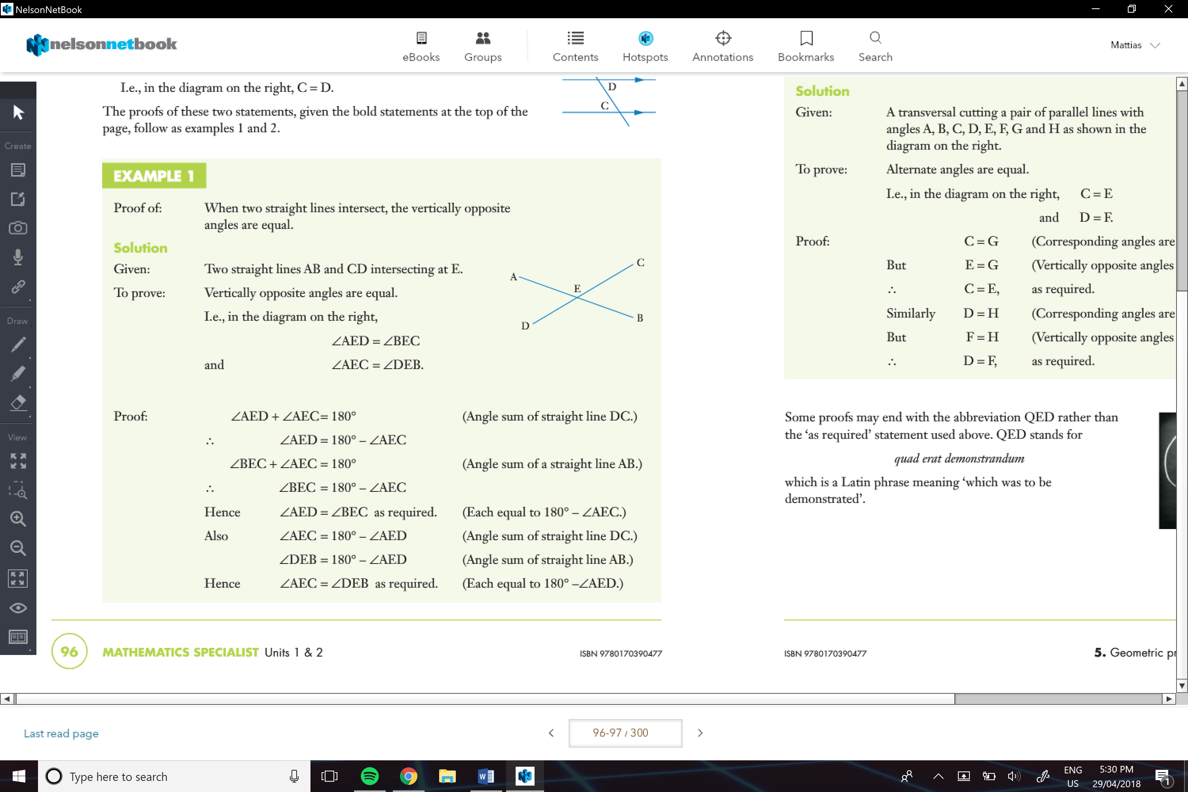
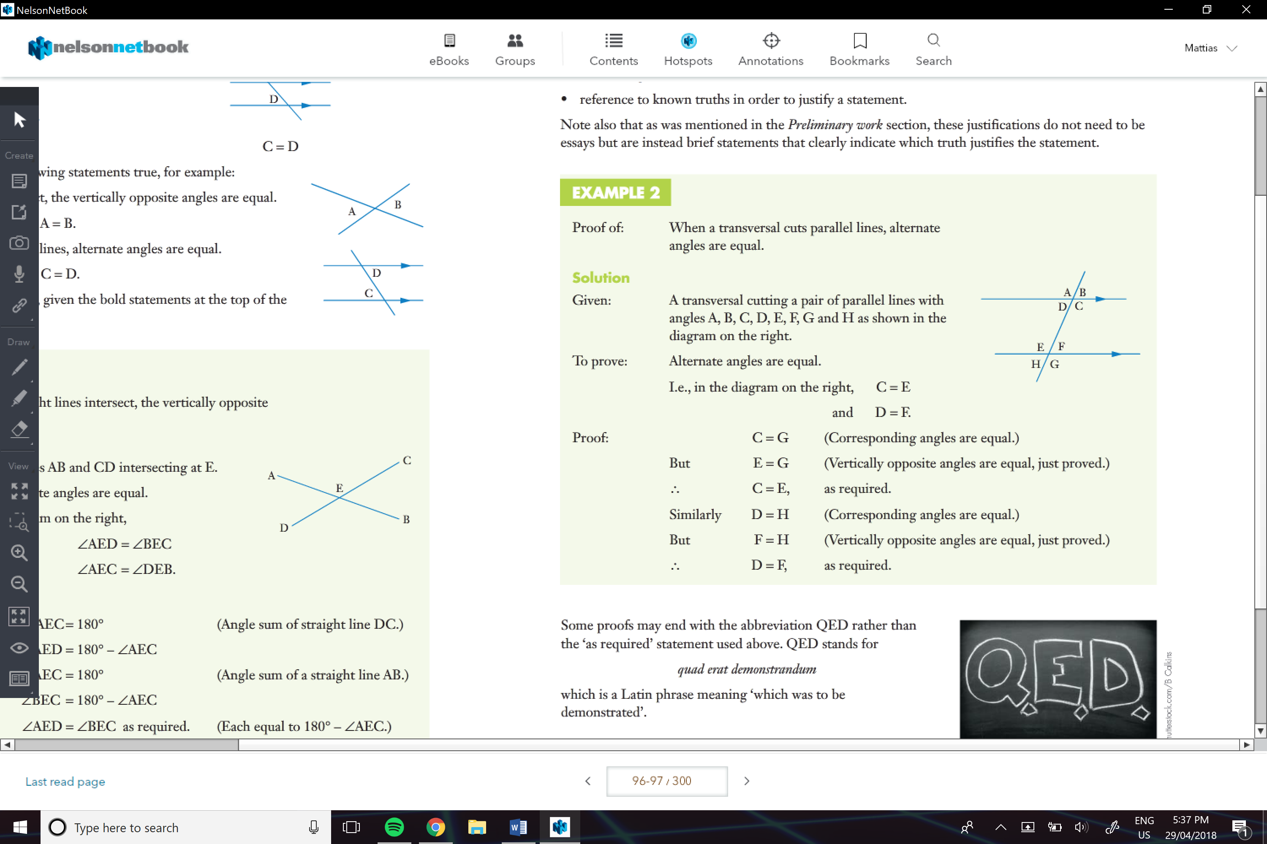
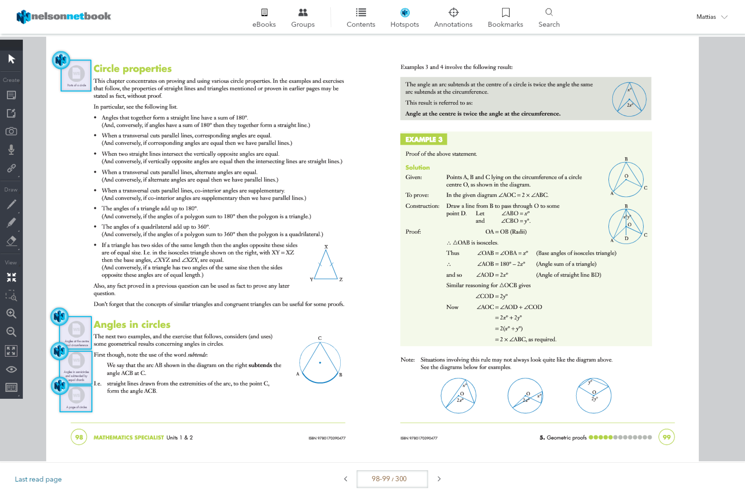
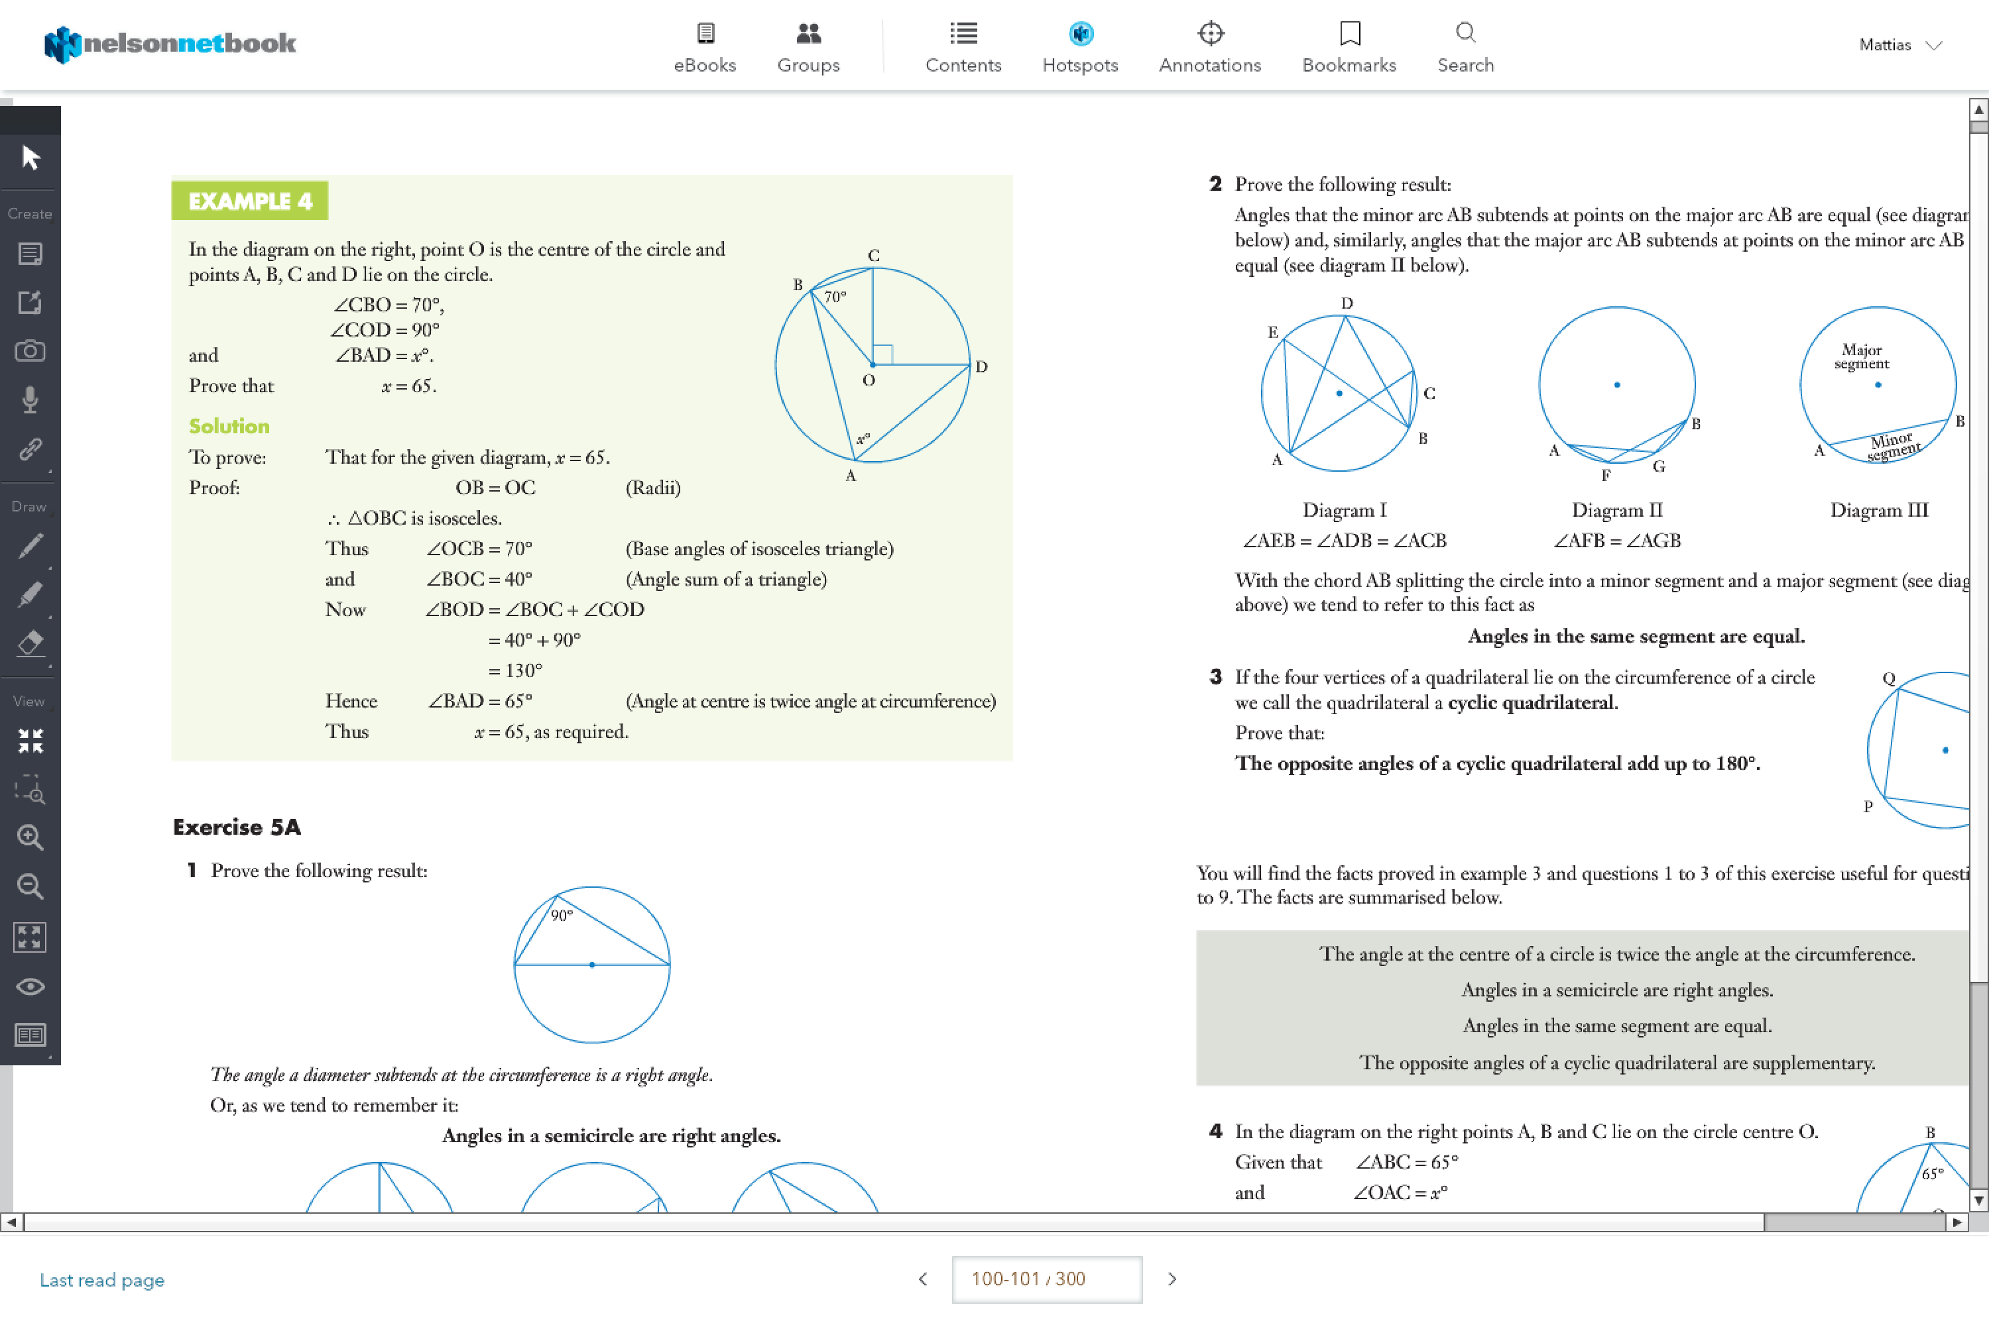
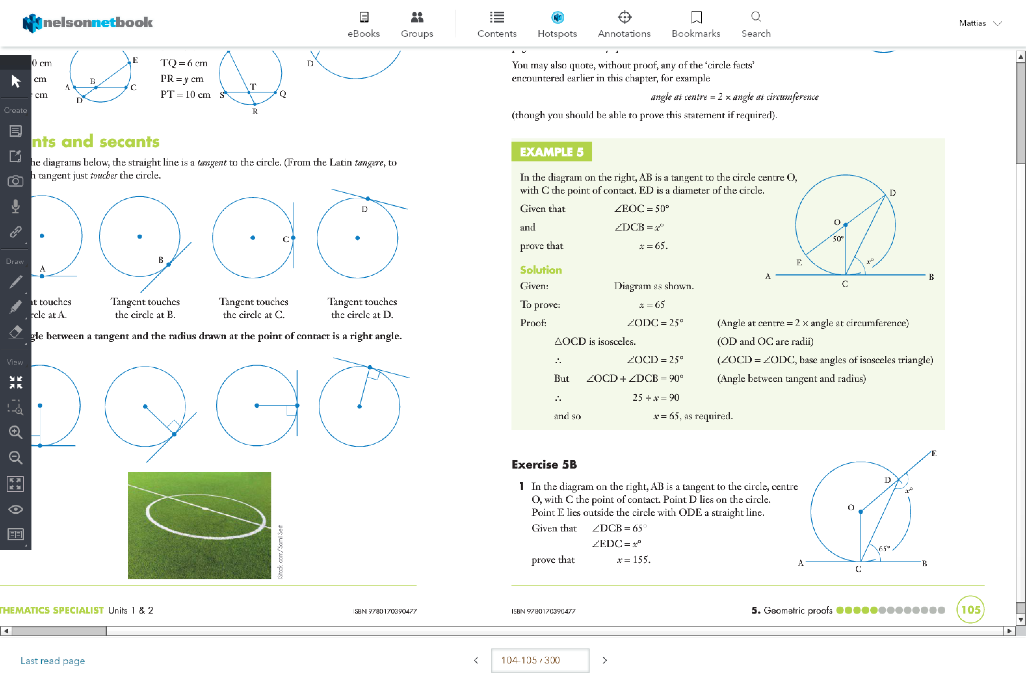
In summary…
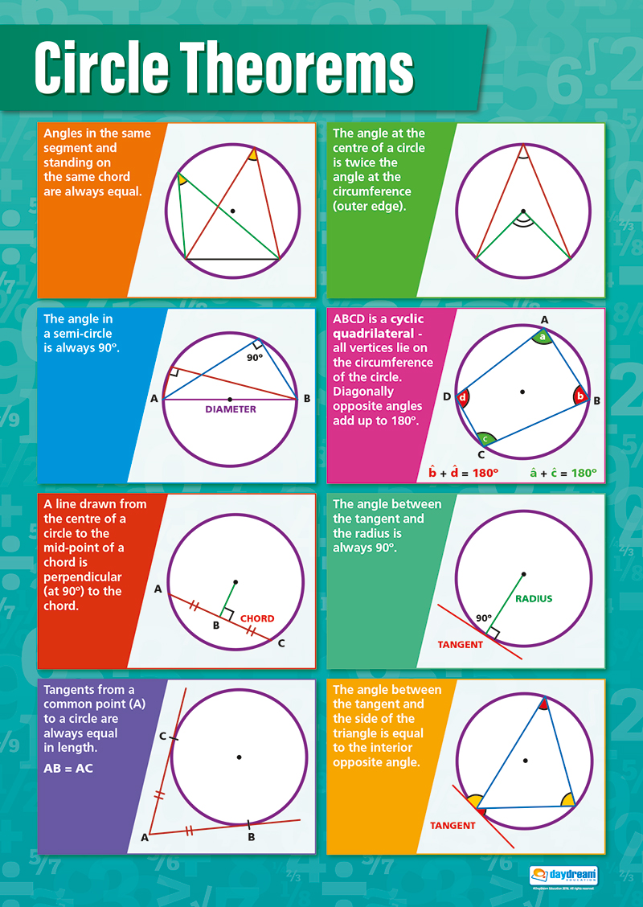

Similar Triangles:
AA
SAS
AAA
SSS
Hyp and S…

